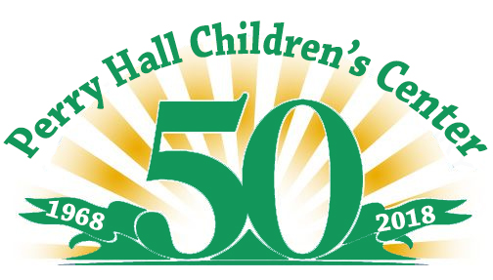
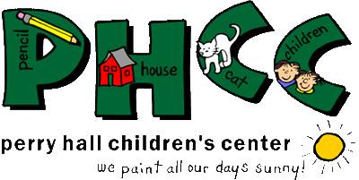
9534 Belair Road, Baltimore, MD 21236
410-529-8224 http://phcccoop.org

Perry Hall Children’s Center is one of the few remaining cooperative preschools in Baltimore County and we rely on the support of the community to continue the work that we do. Located in Perry Hall, the center was founded by a group of parents who recognized the importance of parental involvement in the education of young children. Since 1968, we have been educating the next generation while also preparing them for their academic future. We serve families who have special desire to share in their child’s first school experience. We believe the efforts, individual talents and the direct involvement of the parents during the school day make for a unique educational endeavor. We are a cooperative preschool and the administrative responsibilities of this school belong to the board of directors.

Perry Hall Children’s Center is proud to be celebrating our “50th Anniversary” this year and to celebrate we are having a “Golden Anniversary Bingo Bash” to be held on Friday, November 16, 2018 from 6-10pm. We are asking businesses for their support in helping to make this event a huge success. We anticipate approximately 580 participants. Our goal is to conduct 20 games of regular bingo, 3 special games and 3- 5 raffles with each winner receiving a basket filled with gifts and prizes. The baskets are among the biggest and the best offered in Baltimore County with most the baskets being valued between $500.00 to $1000.00! We have quickly become the Bingo everyone comes too. We have sold out every year!!! This event is our major fundraiser for the year and all of profit goes directly to the school. Please consider contributing to this to PHCC through a donation of Gift Cards, Merchandise or Monetary Donation. The profits will help with the growth and development of our children at Perry Hall Children’s Center.

EVENT SPONSOR: For a donation value of $200.00 or more the basket will proudly be labeled with your business name. You will receive a business card size advertisement space in our program and we will display any advertisement you provide to us at the bingo. Your company will also be announced during the event.

All other DONATIONS: Your donations of gift certificates, gift cards, merchandise or monetary donations will be used to fill the baskets and for other prizes and will be listed in our program and announced during the event.

We are a non-profit preschool and contributing to this event is Tax Deductible! Our Tax ID# is - 52-6082246.

Donations can be mailed to: Perry Hall Children’s Center
9534 Belair Road, Baltimore, MD 21236
Attn: Lindsay Pedersen- Fundraising Chair

We can also arrange for collection of your donation. Please contact Lindsay at 240-426-6117 or by email phccfundraising@phcccoop.org.

THANK YOU for your time and consideration. If you have any questions or require additional information, please don’t hesitate to contact us.
Lindsay Pedersen  Fundraising Chair  240.426.6117  phccfundraising@phcccoop.org | Karen Sipes  Asst. Fundraising Chair  732-598-6704

